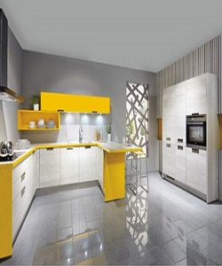

Stylish Kitchen Cabinet

$233.89

Availability: In stock

Description

Modern European yellow and white curved kitchen cabinets. The smooth-surfaced doors are custom made to your kitchen project, and are available in a range of sheen levels, Full assembly instructions are included in the box, certified for the highest quality.